Below is important to coders
Please read. Understand. And execute.
Also remember both start when the light turns on and have to end in 120 sec at the latest

Starting box:
Front → Back
- Create
- Fish Farm
- Manipulator (or arm for short or Mani!)
- Reef starters(these will be in the back, sine we are not using them)
CREATE
Reminder:
- Create is always going backwards to have the sweeper accessory in front.
- Try to find the fastest speed the create can go, but efficiently(without jamming) sweep polyps
- You cannot use camera on this robot, it’s on the manipulator
- These turns will either be left or right, depends on which side of the game board we are on. So be able to change the left and right turns easily. Put comments next to the turns so we know where to change.
1. Go straight & turn sweeper on (the sweeper will continue to be on)
2. Reach the black line (now the create is under the injection chute, add the polyps to the Create's basket)
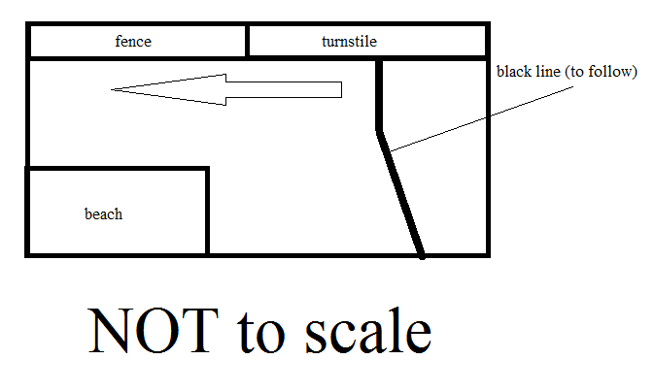
3. Follow the black line towards the turnstile
4. Using distance sensor, find when you are almost at the turnstile
5. Stop before touching turnstile
6. Follow the fence going towards the beach
7. Reach the PVC (end of game board)
8. Turn so the Create faces the started box (turn left approx. 90 degrees)
9. Go forward the length/diameter (since it’s a circle) of the Create
10. Turn Create so that it faces the mpa side of the board (turn left approx 90 degrees)
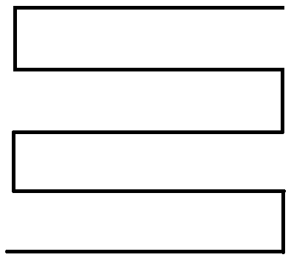
11. Go straight – continue (the S shaped motion, picture to right) until the Create has completely covered the board (make sure it doesn’t hit the fish farm; maybe make it only go until the black tape?). This is to check that the Create has got all the polyps
12. Go to the mpa and when the sweeper makes contact, lift it (the sweeper)
13-14. Push “wall” and polyps out, retract the “wall”, and then push “wall” and polyps out again
15. Drive Create somewhere so that it does not block the armbot
DONE
So this requites 2 different codes
1) The steps above from 1- 12 for the robot to move. All the while the Create is doing it backward and with the distance sensor. This requires a sensor(s) and motors.
2) This is steps 13- 14. This is also partially hardware because you need to keep testing it and to make sure the sweeper accessory works smoothly with the code. This requires servos and motors.
If you are a coder please choose which one you would like to do. Then maybe we'll separate the coders into teams that focus on one of the 2 jobs.
MANIPULATOR (armbot)
1. Go straight (arm is in front and the claw start off open) and push the fish farm in front of the injection chute
2. Reach the black line and leave the fish farm here, later you may have to back out and go around fish farm so it isn't moved
3. Follow the black line towards the turnstile
4. Stop before touching turnstile
5. Now that you are perpendicular to the turnstile, turn right so you are facing the corner, which the 3 blocks are randomly placed.
6. Using the camera, locate the yellow block
7. Head towards yellow block (the claws are still open)
8. Put claw around yellow block and close the claw
9. Lift up yellow block the height of a block + 1in (so 5in)
10. Locate blue block with camera
11. Go towards blue block, with yellow block still in claw
12. Place yellow block on top of blue block (for this, some measurements may need to be calculated to see how far away the armbot will need to be to gently place the block down.)
13. Back away from the stack. Claw is open again (from releasing the block)
14. With camera, locate red block
15. Repeat steps 8 to 9, but with the red block. And in step 9, lift up the red block (measurements will need to be made to see how high we lift the last block, although I think its approx. 9in)
16. Do not touch the stack, will need to somehow identify the stack and not touch it, or place it in the mpa. If we place it into the mpa we do not need to worry about crashing into it
(Right now the blocks would be stacked in or from bottom to top: blue, yellow, and red. They are stacked on top of the semi randomly place blue block)
17. Find black line
18. Follow black line to turnstile
19. Face the starter box side (turn left at approx 90degrees), and follow the fence to the end of the game board/ PVC pipe do this at fastest speed, but don't fall off game board
20. Turn left (arm is not facing fence)
21. Lift arm up so it will be the right height to grab the brain coral
22. Go forward the length of the arm + robot body + 1inch(to leave space between the arm and the brain coral, so when the robot spins with the arm the same height as the coral it won’t accidentally hit the coral.)
23. Turn in a circle 180 (arm is not 1in away from the brain coral)
24. Go forward 1in and close claw
25. Turn right, now against the wall go forward until you reach the black line
26. Follow black line (don't crash into create, use camera? or maybe create is out of the way. Actually find a spot on the line that the arm robot can stop that doesn't touch the create)
27. Turn left, so the arm is directly over the mpa
28. Lower arm and place brain coral in mpa.
29. Get the 2nd brain coral in the same manner, and place it into the mpa
DONE
So that's how the robots will be moving! Learn to code, so we can get to test the robots!

